Smart Line Tracking Robot for Targeted Location Navigation

KARAM HAIDAR std #20223390 [https://orcid.org/0009-0003-8398-7735], KERANA NGOIE std #20205689 [orcid.org/0009-0004-0945-8023]

Near East University, Faculty of Engineering, Mechatronics Engineering Department, Nicosia, 99138, North Cyprus

**Abstract.** Robot Line Tracking is a smart system that allows a robot to detect and follow a line, typically drawn on the floor. The system uses various methods such as sensors, cameras, and algorithms to achieve this functionality. [1]

In our project, we used IR sensors to detect black line on the floor. Here are some key points about the robot line tracking:

Implementation: The implementation of line tracking involves the use of various technologies such as fuzzy logic controllers, PID algorithms, optical sensors, and image processing techniques like edge detection and Hough transform. [2]

Navigation Methods: Navigation methods for line tracking robots can include line tracking and algorithm based on a QR code map, which is used for path planning. [3]

Control Strategies: Various control strategies, including proportional integral-derivative (PID) control, have been widely implemented in line tracking robots for achieving time-optimal path tracking. [4]

1. Introduction

As technology becomes more significant in today’s life, it is important to know and understand how use it. This Project is a robot which is a combination of hardware and software. Being a future mechatronics engineers, we rely on different field through it to make the connection between electrical, electronics, software, and programming skills. [5]

Line following robot is a self-operating machine that detect and follow either black or white line on its path.

The core components of this robotic system include two IR sensors acting as the robot's eyes, an ESP32 microcontroller serving as the brain, and four-wheel motors providing the necessary mobility. The interaction between the IR sensors and the microcontroller enables the robot to make real-time decisions based on the detected line conditions, allowing it to intelligently navigate towards predefined points. [6]

Furthermore, the integration of a web-based control interface adds a layer of sophistication to the project. Through HTML website and Wi-Fi connectivity, users can dynamically select specific locations for the robot to navigate. The robot responds to these commands, showcasing its adaptability and responsiveness in reaching user-defined points.

In the following lines, the construction and working of different components used will be given in details.

1. Components and Methods
   1. Hardware Design

The line-tracing robot consists of five basic components: two infrared (IR) sensors (Figure 1), a microcontroller (ESP32), four-wheel motors, a battery, and L298N motor driver. These components form the basis of a line tracking robot system as shown in the **Fig.5.**

1. Infrared Sensors (IR):

IR sensors can detect the guidance line and determine the position of the robot. Their ability to perceive changes in reflected brightness allows the robot to recognize and follow the desired path with high accuracy [7]. The microcontroller can translate sensor data (IR) into information about direction, position movements, and displacement.

1. Microcontroller ESP32:

It is the core of the system, and the decision maker for the robot. As shown in (Figure 3), it consists of a microprocessor chip, memory, I/O ports, and integrated Bluetooth/Wi-Fi devices.

The designed program can be downloaded from the PC to the console via the appropriate connection cable (USB cable) which is saved in memory as long as no other program is loaded. It processes data collected through its input ports and makes intelligent decisions based on infrared sensor data, web server data, and the robot's current location. Next, the microcontroller sends control signals to the L298N motor driver through its output ports to implement what it has decided. [8].

1. Motors and L298N Driver:

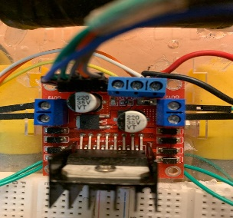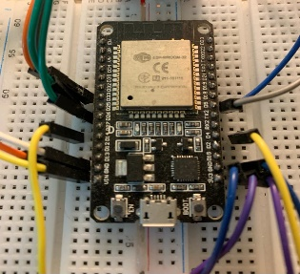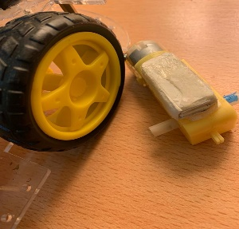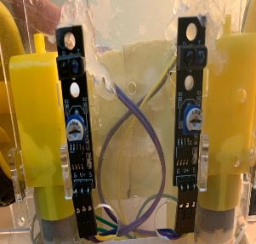The robot's kinetic energy is driven by four synchronous wheel motors (Figure 2). The microcontroller is an important intermediate with the L298N motor driver which can pass high amperes to control the speed of DC motors (Figure 4). The movement of these actuators in the direction specified by the user places the designed robot model in the specified direction - whether to move forward, stop, or perform a left or right turn.

**Fig.1.** IR Sensors **Fig.2.** Wheel motors **Fig.3.** ESP-32  **Fig.4.** Driver

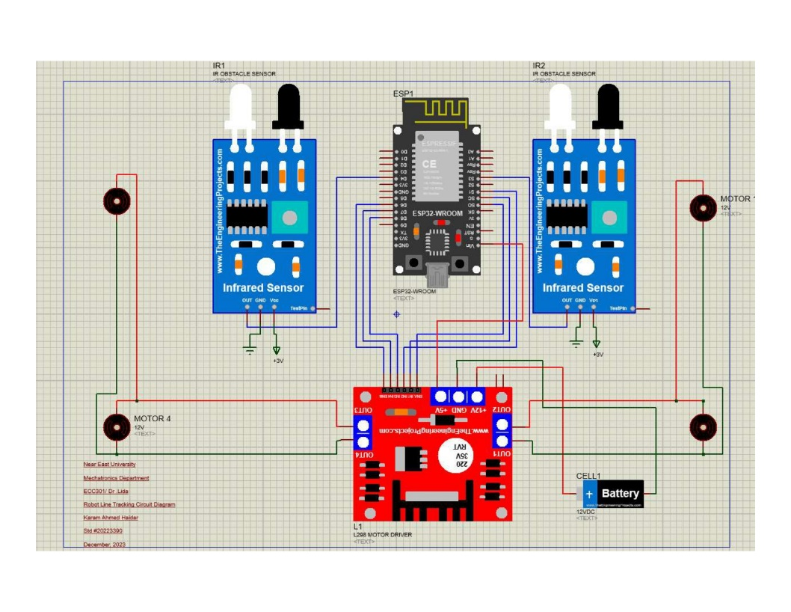

**Fig.5.** Circuit Diagram of Line Tracking Robot

* 1. Software Design

The behavior of the robot is determined by the readings from the sensors, referred to the left and right sensors. Here's a breakdown of the robot's actions based on the IR conditions:

1. Forward Motion:

The robot moves forward when the two infrared sensors detect a bright condition. Synchronized action of equal speed motors drives the robot forward along the specified path.

1. Left Turn:

If the right IR sensor senses a bright condition while the left IR senses a dark condition, then the ESP-32 will execute a left turn function to correct the path (Fig6).

1. Right Turns:

Conversely, if the right IR sensor senses a dark condition and the left IR senses a bright condition, then the ESP-32 will execute a right turn function to correct the path (Fig8).

1. Stop:

When the two infrared sensors detect a dark condition simultaneously and the target location is reached, the ESP-32 will perform an off function to stop the robot (Figure 7).

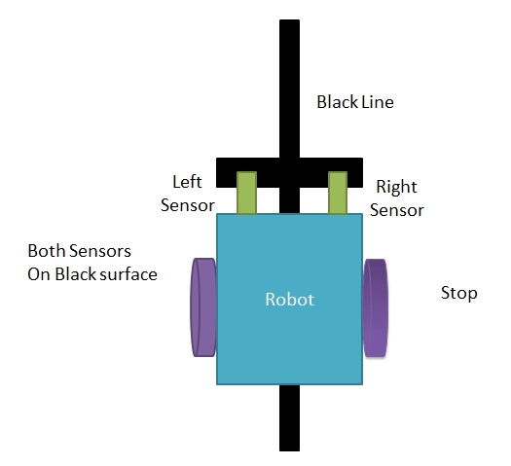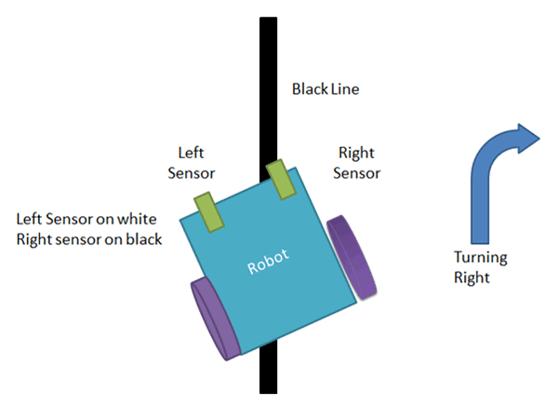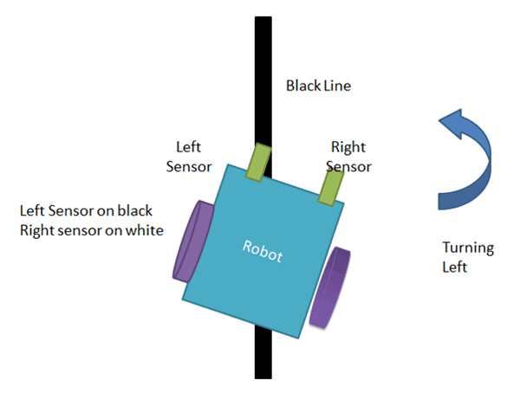

**Fig.6.** Should be turned Left **Fig.7.** Stopping **Fig.8.** Should be turned Right

* 1. Line Tracking Robot control system

The line tracking robot with a web-based control system provides a versatile and interactive solution for precise navigation. The web interface is designed by HTML, allowing users to control the robot's movements over Wi-Fi.

Target selection algorithms shown in fig.9, rely on calculating the target's coordinates relative to the robot's current location (which are the paths the robot will take), while specifying an indicator of the robot's direction when each target is reached.

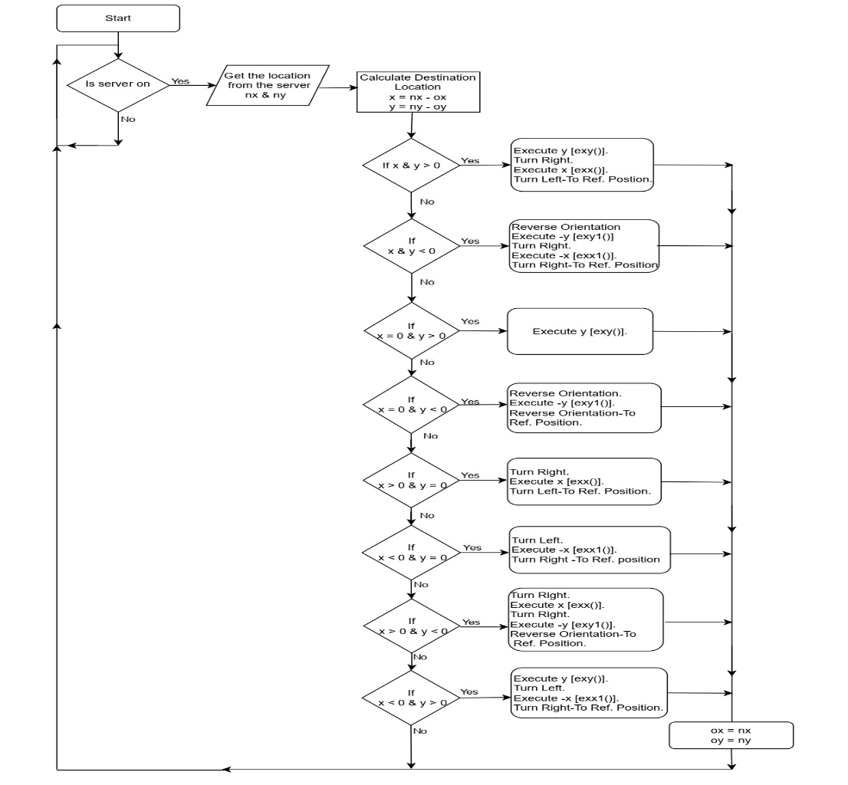

**Fig. 9.** Flowchart of the Line Tracking Robot.

1. Results and Discussions

The line tracking robot project overcame some challenges in design and implementation, such as:

Calibration of commercial motors to obtain a uniform speed that ensures the robot's movement in a straight line, by calibrating and adjusting the speed values ​​for each motor fed from the ESP32 and L298N Driver.

Improve the robot's rotation accuracy by adjusting the time delay when turning, ensuring good consistency for right, left and reverse turns. Taking into account the state of battery charge.

The algorithm for determining the target shown in Fig. 9 (The location of the robot’s arrival) chosen by the user was one of the challenges in designing the program and may not be the best, but it is the most appropriate and simplest given the available capabilities.

The microcontroller interprets the selected point, calculates the required movements in terms of X and Y coordinates, the robot performs forward movements, turns, and stops based on the calculated values to direct itself to the destination location.

1. Conclusions

A rule-based line-tracking robot was implemented, and employed a navigation algorithm. The robot is represented by two IR sensors, interact with the ESP32 microcontroller, facilitating real-time decision-making based on detected line conditions to incorporate forward movement, right, left, and reverse turns, as well as a complete stop.

To enhance user interaction, a web-based control interface using HTML over Wi-Fi connectivity allowed users to dynamically select specific locations for the robot to navigate, showcasing its adaptability.

Furthermore, the advantage of this system is that it is reprogrammable, so any upgrade can be performed simply by uploading the update-software, and it is also suitable for innumerable other applications.

References

1. <https://ieeexplore.ieee.org/document/5380235>.
2. https://forums.raspberrypi.com/viewtopic.php?t=2114 09.
3. <https://ieeexplore.ieee.org/document/7044874/>
4. <https://www.researchgate.net/publication/322469538_Ziegler-Nichols_Based_Proportional-Integral>Derivtive_Controller_for_a_Line_Tracking_Robot.
5. <https://embedjournal.com/line-follower-robot/>
6. MAJAU AGRIPHINA MUGURE, "DESIGN AND FABRICATION OF-AN AUTONOMOUS LINE FOLLOWER ROBOT"
7. <https://www.futurelearn.com/info/courses/robotics-with-raspberry-pi/0/steps/75899#:~:text=Infrared%20(IR)%20detection,example%20TCRT5000%20line%20sensor%20below>.
8. https://www.nabto.com/guide-to-iot-esp-32/